Lewis and Clark Encounter Black Snakes
On July 23, 1805 while on the Missouri River near modern day Townsend, MT, Meriwether Lewis observed an unusual snake: “I saw a black snake today about two feet long the Belly of which was as black as any other part or as jet itself. it had 128 scuta on the belley 63 on the tail” (Lewis et al. 2002). Based on this account, subsequent investigators (Coues 1893; Burroughs and Carricker 1995; Cutright 2003) have given Lewis credit for the first description of a Western Hog-nosed Snake (Heterodon nasicus). This is likely an error. In recent decades, herpetologists have documented melanistic garter snakes in Broadwater Co. near Townsend, MT that are jet black in appearance. However, it has remained unclear whether the individuals are polymorphs of the Common Gartersnake (Thamnophis sirtalis) or Terrestrial Gartersnake (T. elegans) as both occur in the county (Werner et al. 2004). Carroll biology students analyzed scale phenotypes to compare melanistic individuals with typical morphs of T. sirtalis and T. elegans from one hibernaculum near Townsend, MT.

Using the specimen data in the EXCEL file below and scale phenotypes described by Rossman et al. (1996), students will use the one meristic measure (the number of supralabial scales) and three linear ratios to characterize each specimen. Length ratios included: 1) the prefrontal scale length relative to the internasal scale length (PF/IN), 2) anterior chin-shield length relative to the posterior chin-shield length (ACS/PCS), and 3) the muzzle length relative to the frontal length (ML/FL). Together with the supralabial count (usually 8 for T. elegans versus 7 for T. sirtalis), these linear morphometrics are the most disparate measures between T. sirtalis and T. elegans (Rossman et al. 1996) providing the best opportunity for phenotypically delineating the two species and melanistic individuals.

Using appropriate frequency and comparative inferential statistics, which species do the melanistic snakes most likely belong to?

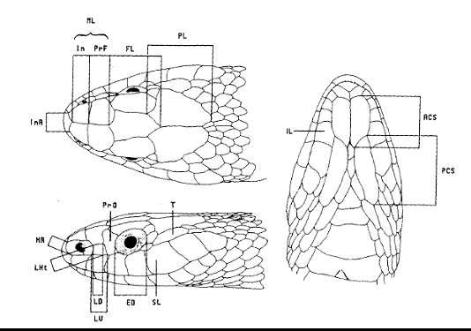
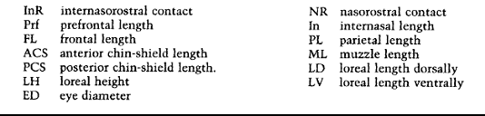

Figure 1. Scale phenotypes as described by Rossman et al 1996.

